**Chatbot Test Plan: Using Python + Flask and Juji Studio LLM Chatbot results**

To test the chatbot based on Chapter 3 of the BABOK, using the "American Hospital Supply Corporation: The ASAP System (A)" case, the focus would be on how well the chatbot guides a user through the business analysis planning and monitoring tasks outlined in the BABOK, as applied to this IT project. Here’s a suggested structure for the test, including sample questions asking the chatbot for each section of the BABOK Chapter 3 tasks. ***The 1st Screen shots are showcased for the results and outcomes from Python + Flask and below that are from Juji Studio.***

**1. Plan Business Analysis Approach (Task 3.1)**

* **Objective:** Assess how the chatbot helps define a structured approach to business analysis for the ASAP system rebuild.
* **Sample Questions:**
  + "What should be the key considerations when planning the business analysis approach for an IT rebuild in a healthcare environment?"

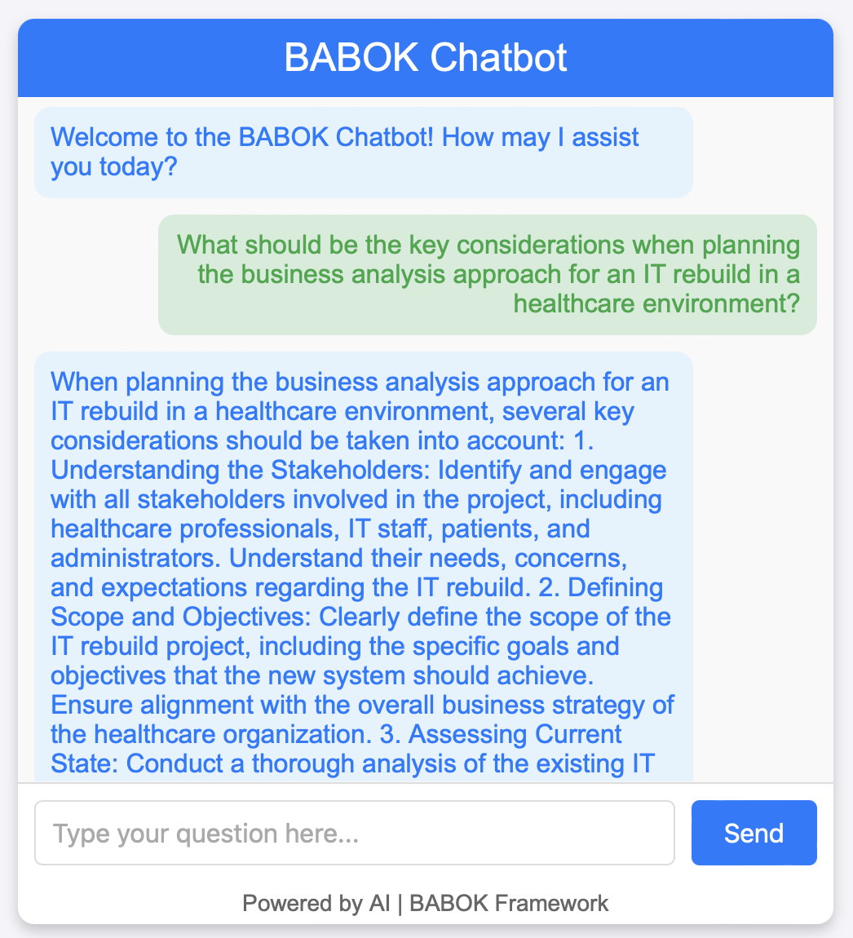 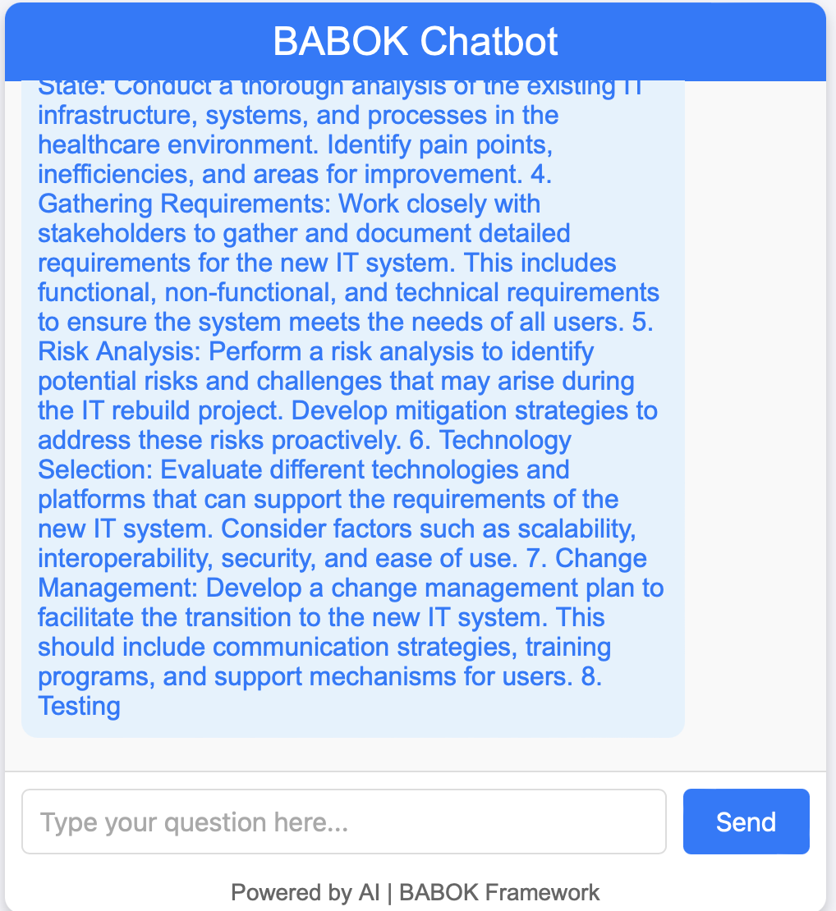

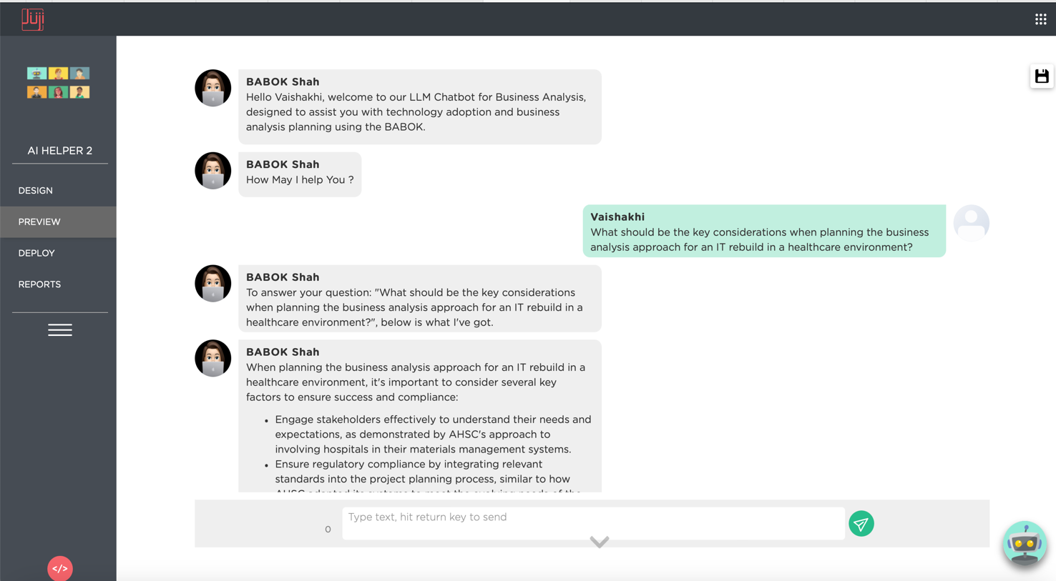

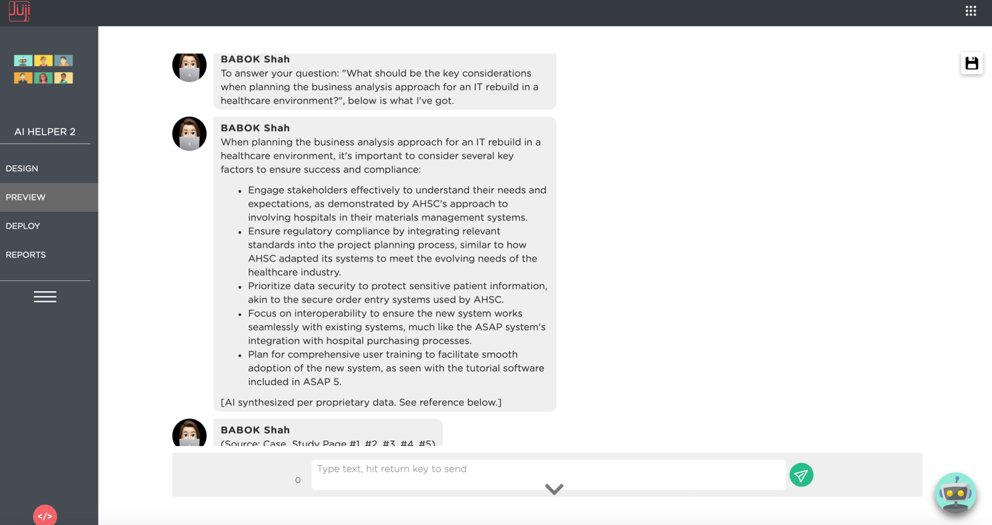

* + "How should the approach account for regulatory and compliance requirements relevant to the healthcare sector?"

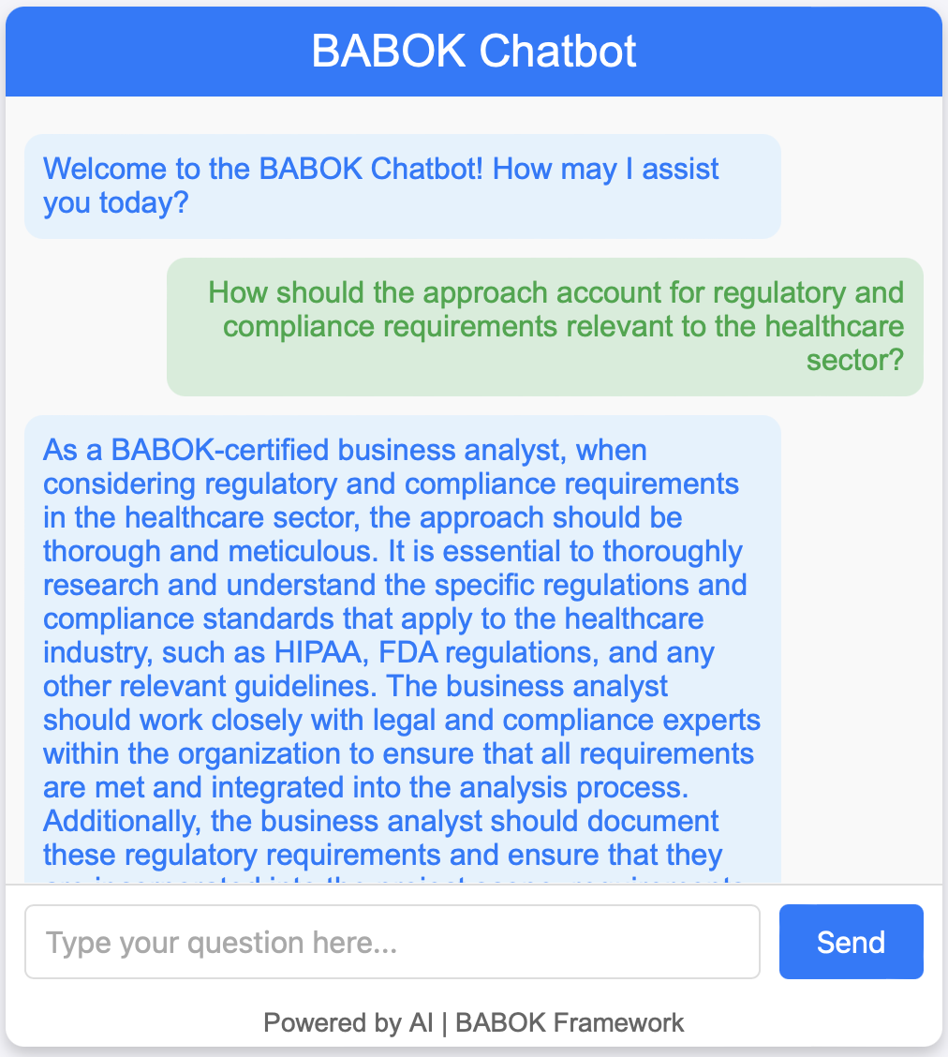 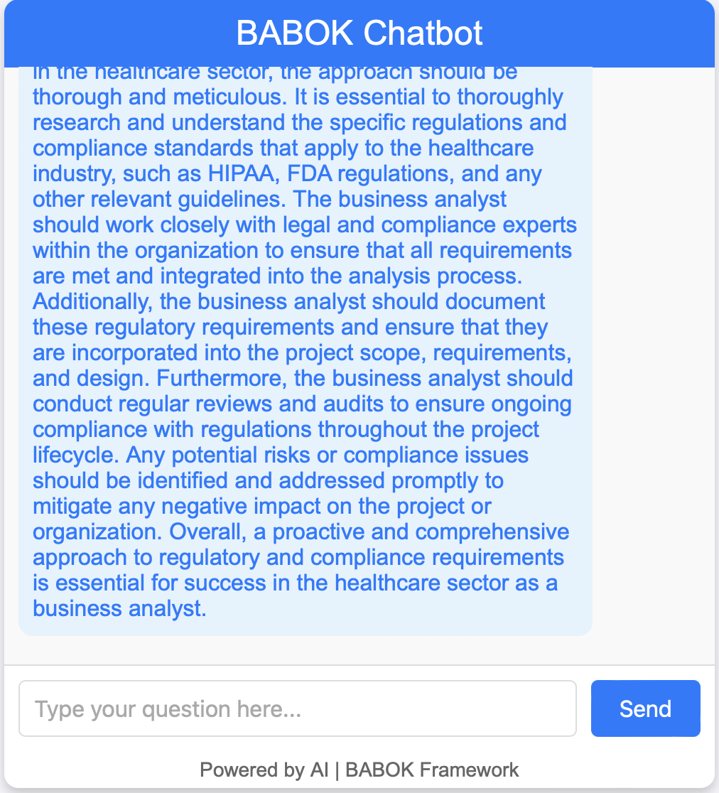

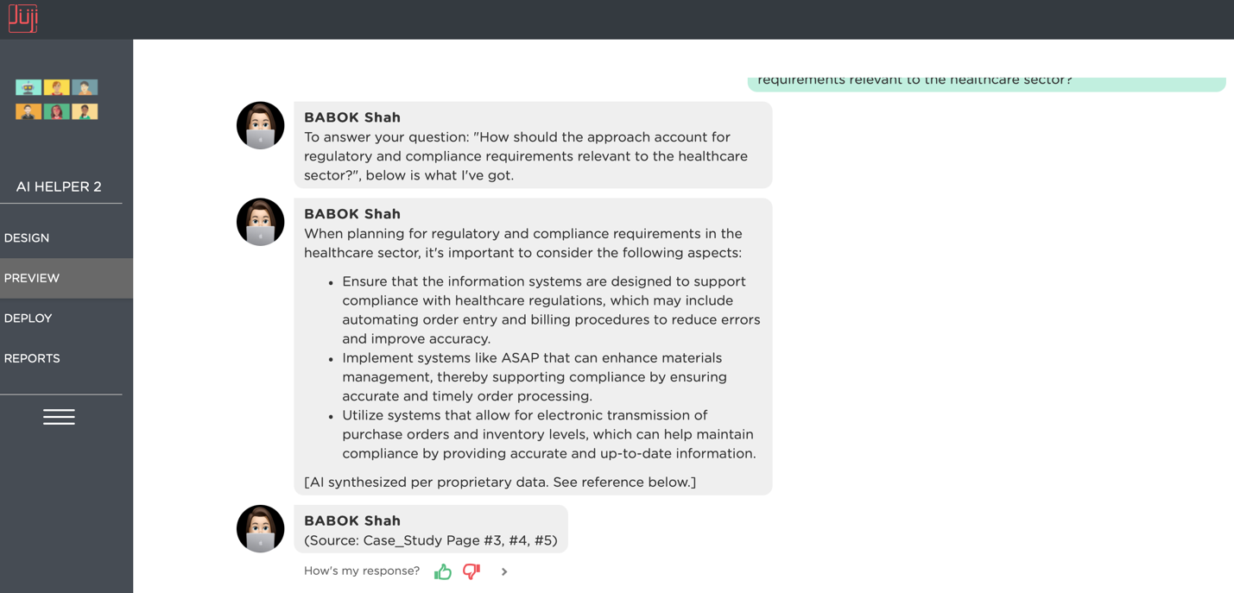

* + "Given that the ASAP system has several versions, how should we prioritize features or functionalities for the rebuild?"

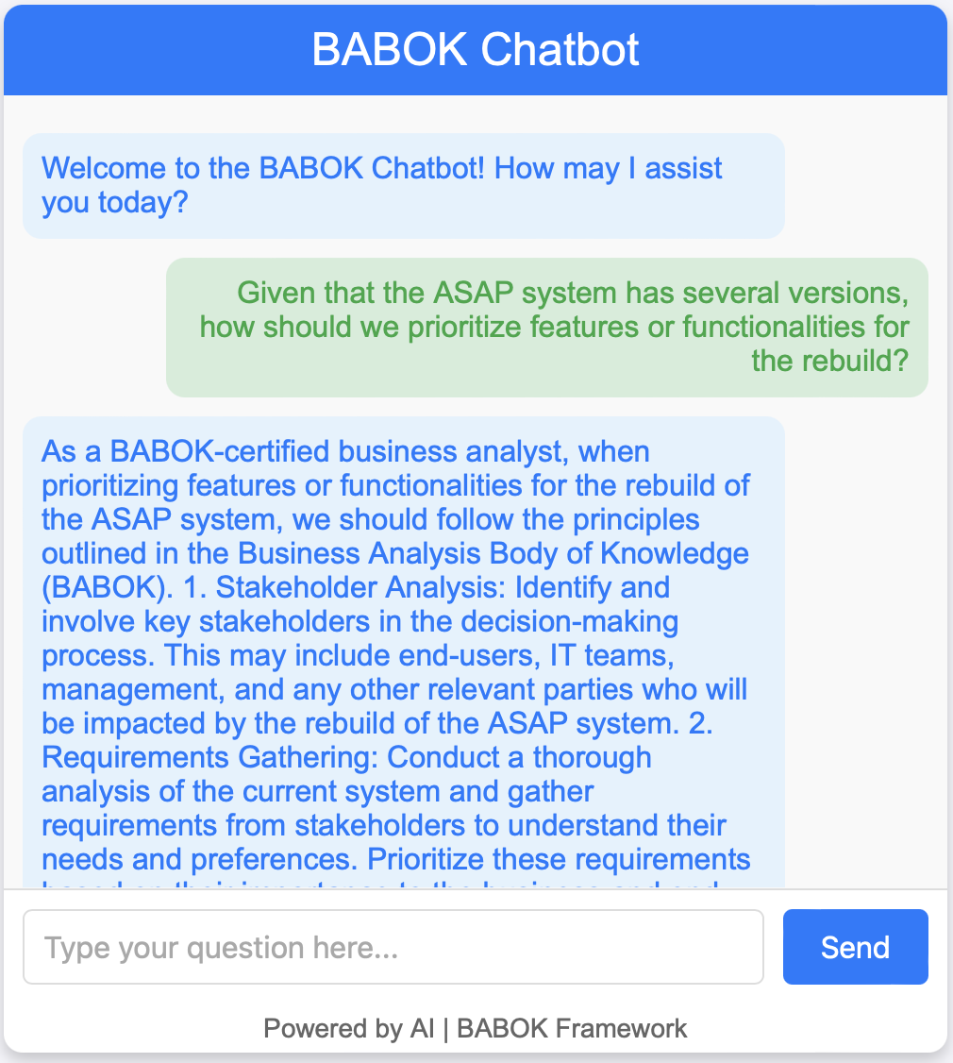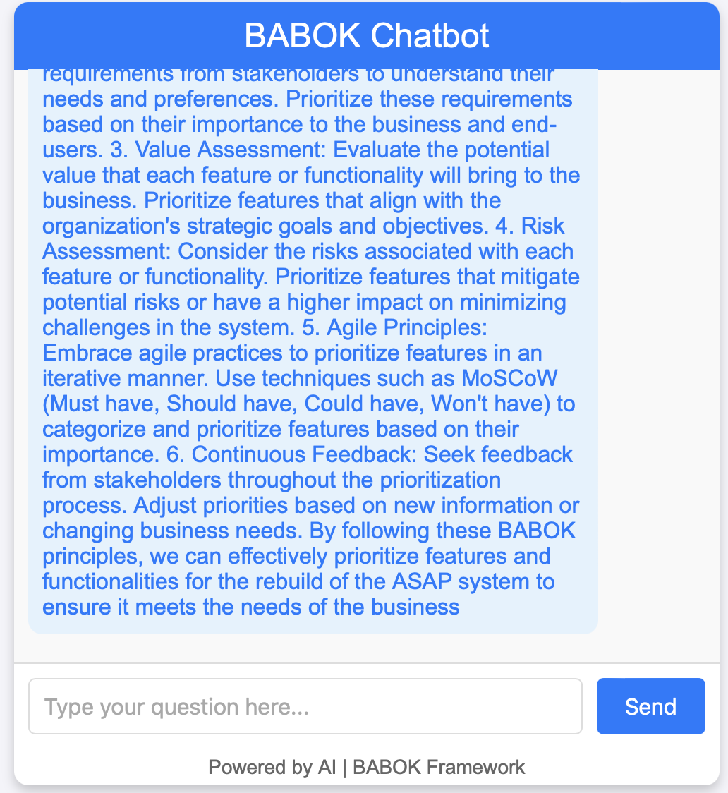

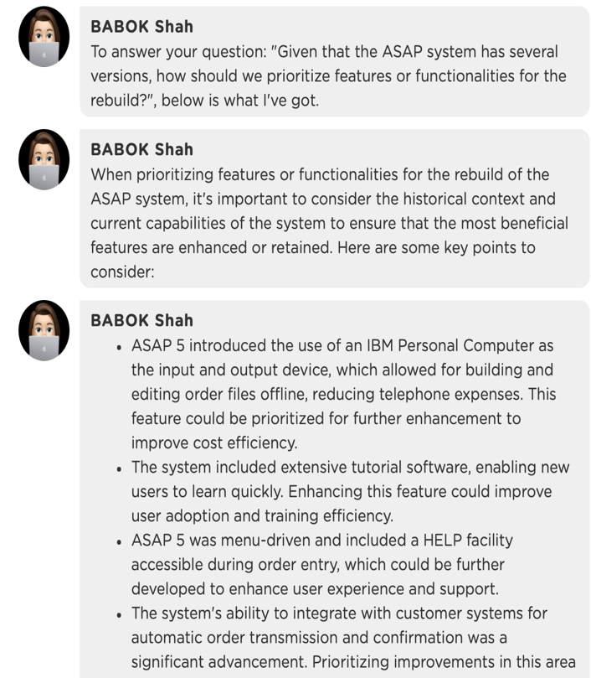 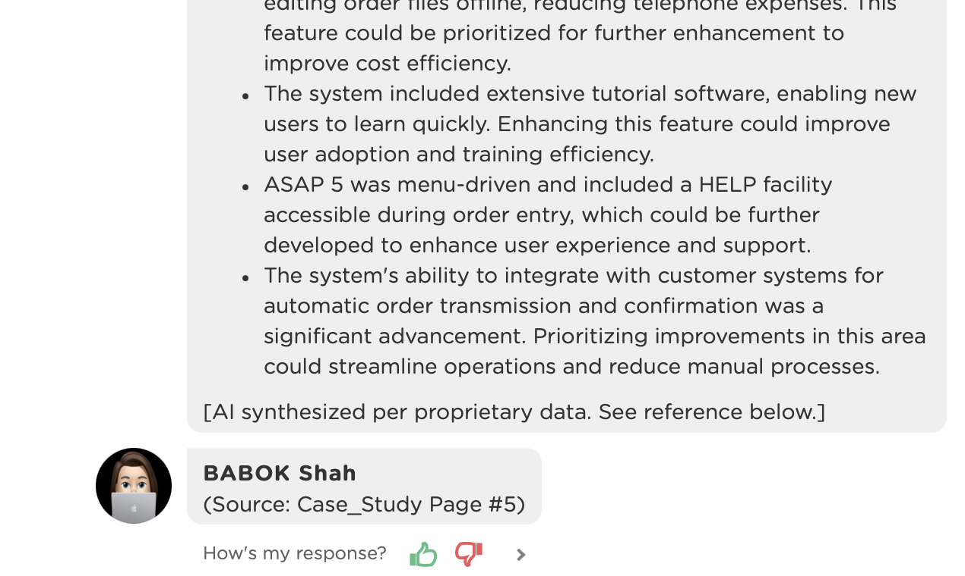

**2. Plan Stakeholder Engagement (Task 3.2)**

* **Objective:** Evaluate if the chatbot can help identify and analyze stakeholders effectively.
* **Sample Questions:**
  + "Who are the primary stakeholders in the ASAP project at American Hospital Supply Corporation, and what are their interests?"

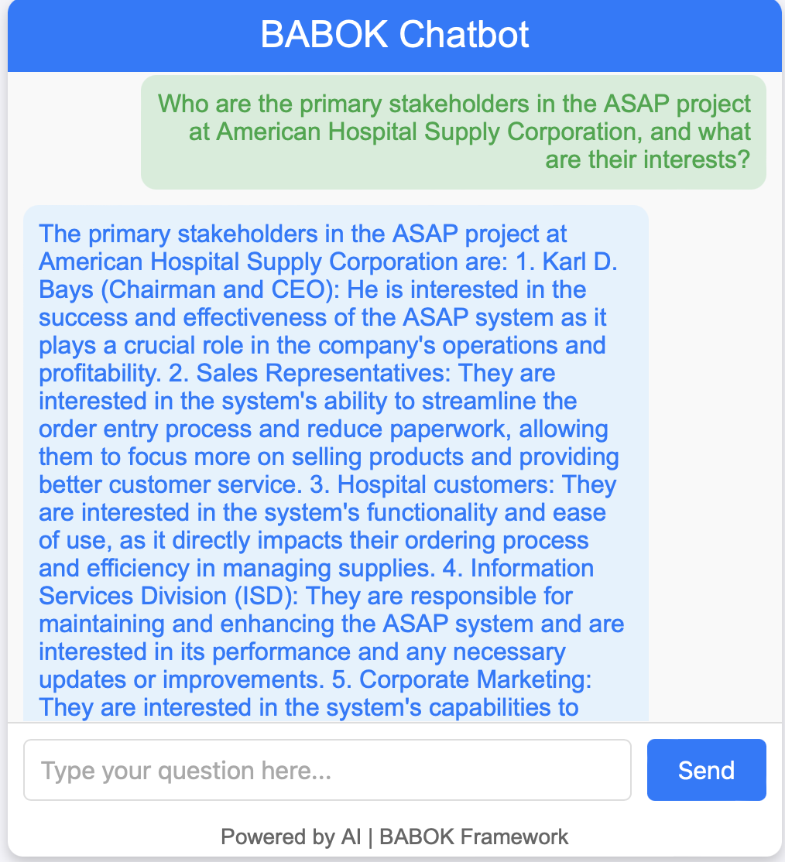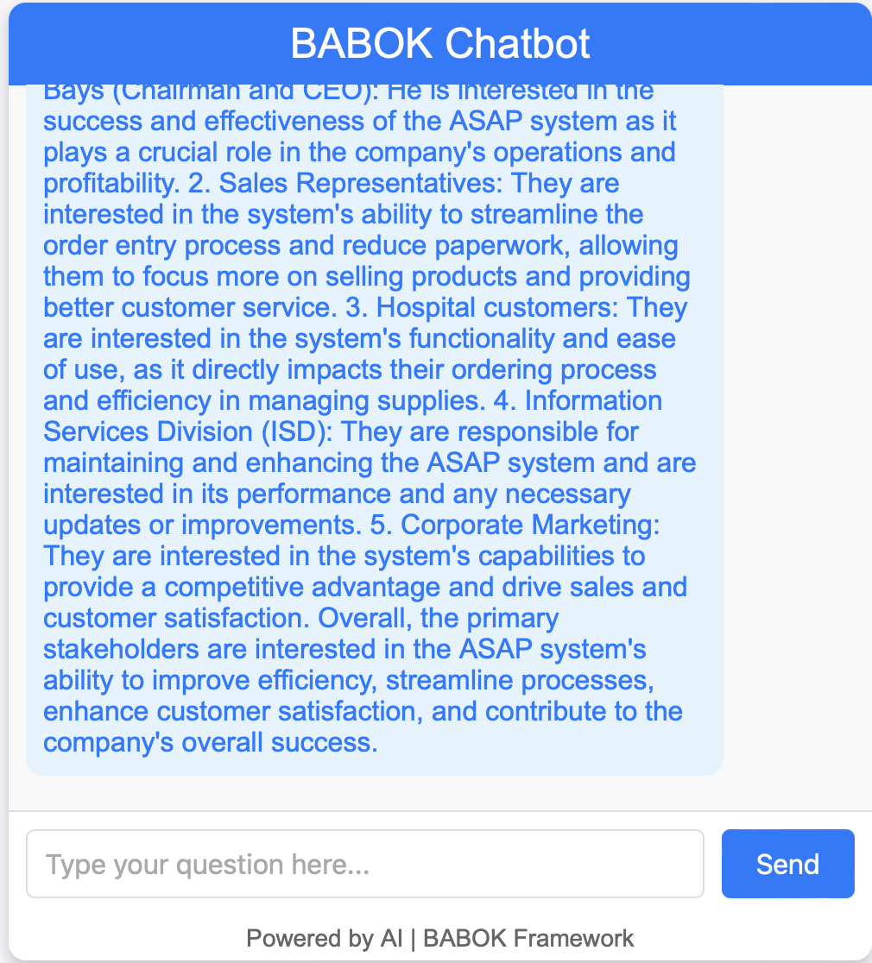

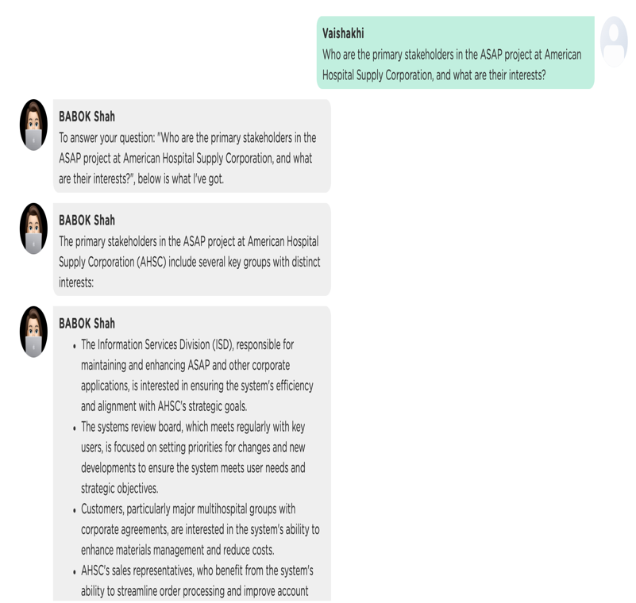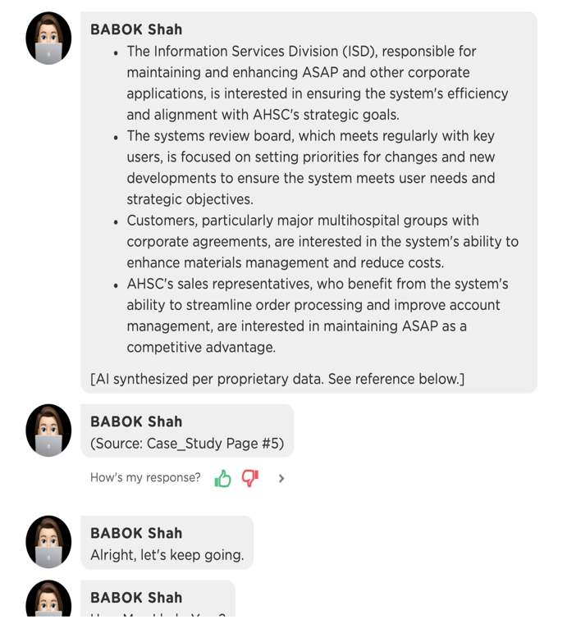

* + "How should we manage stakeholder expectations for a complex IT system with both internal and external users?"

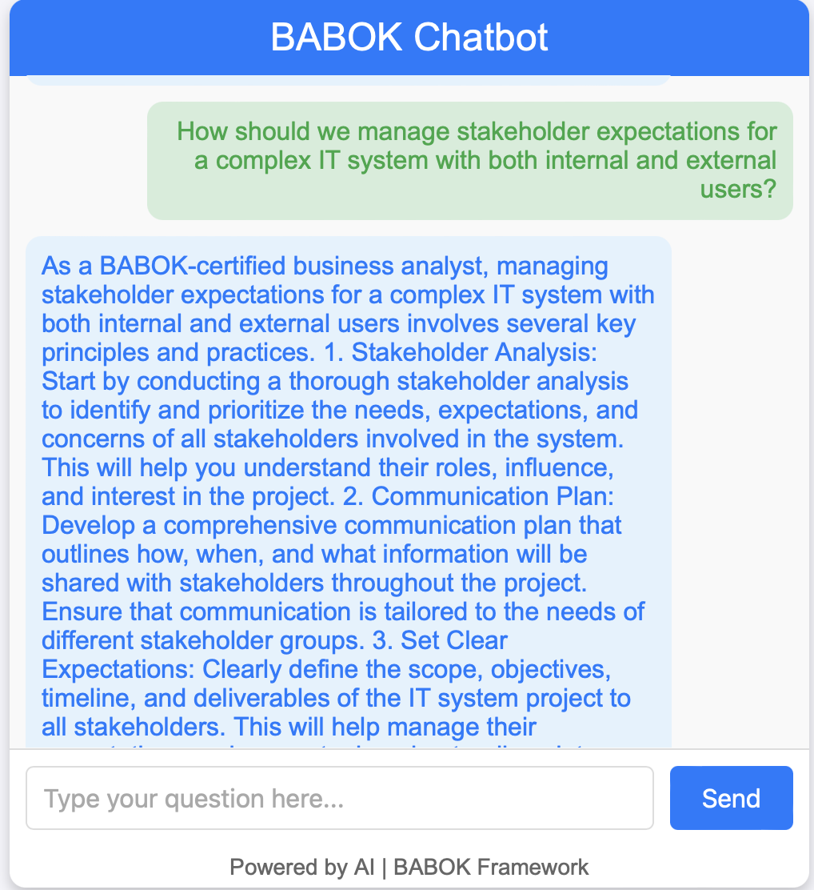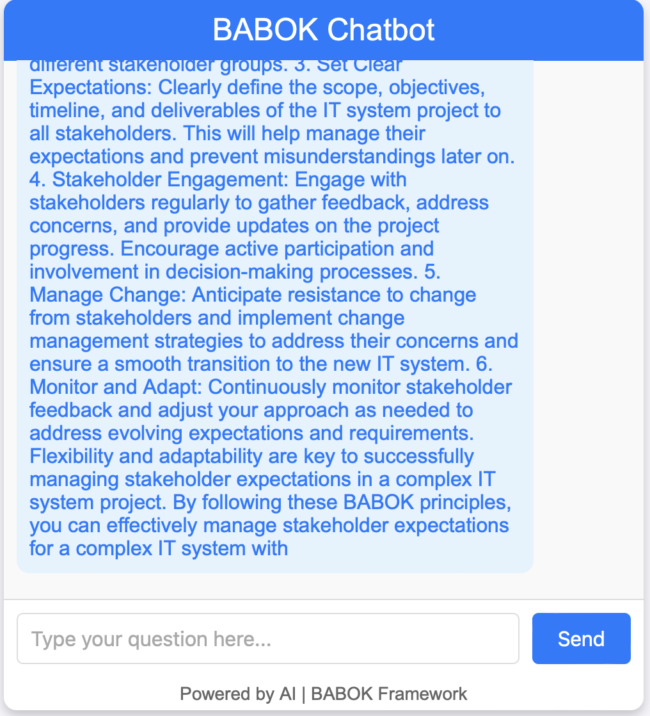

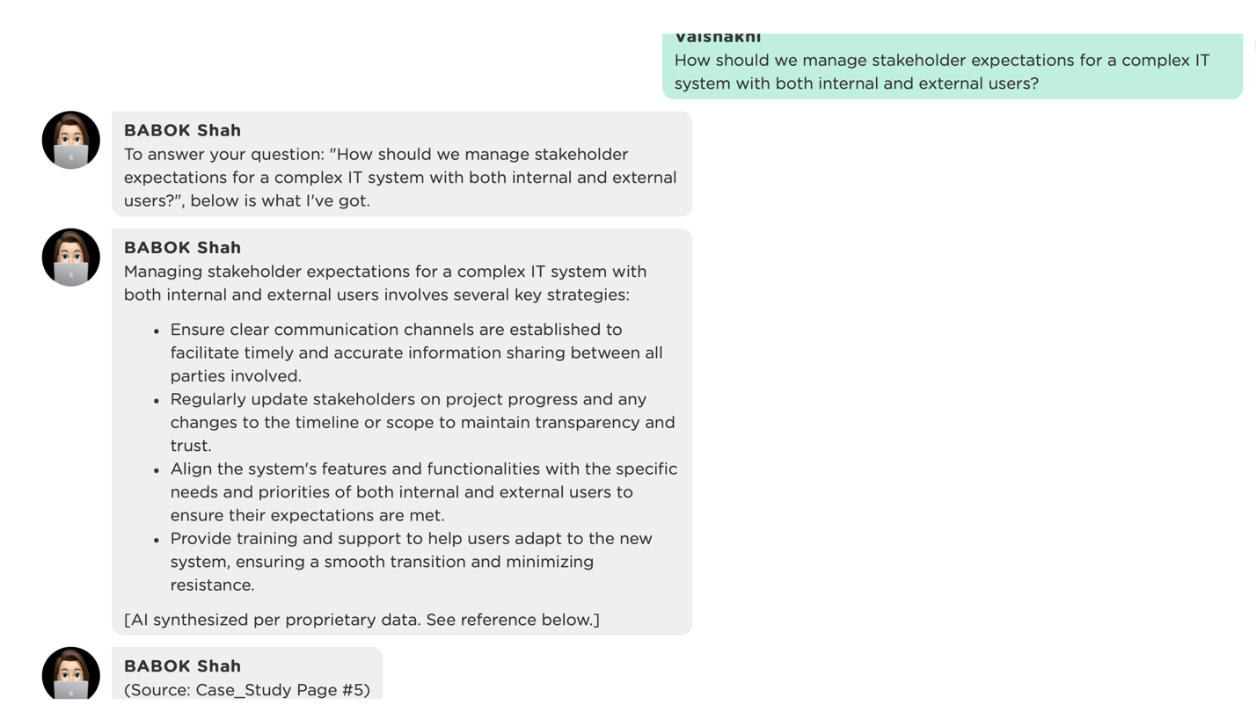

* + "What strategies can we use to ensure effective engagement and communication with hospital clients and suppliers during the rebuild?"

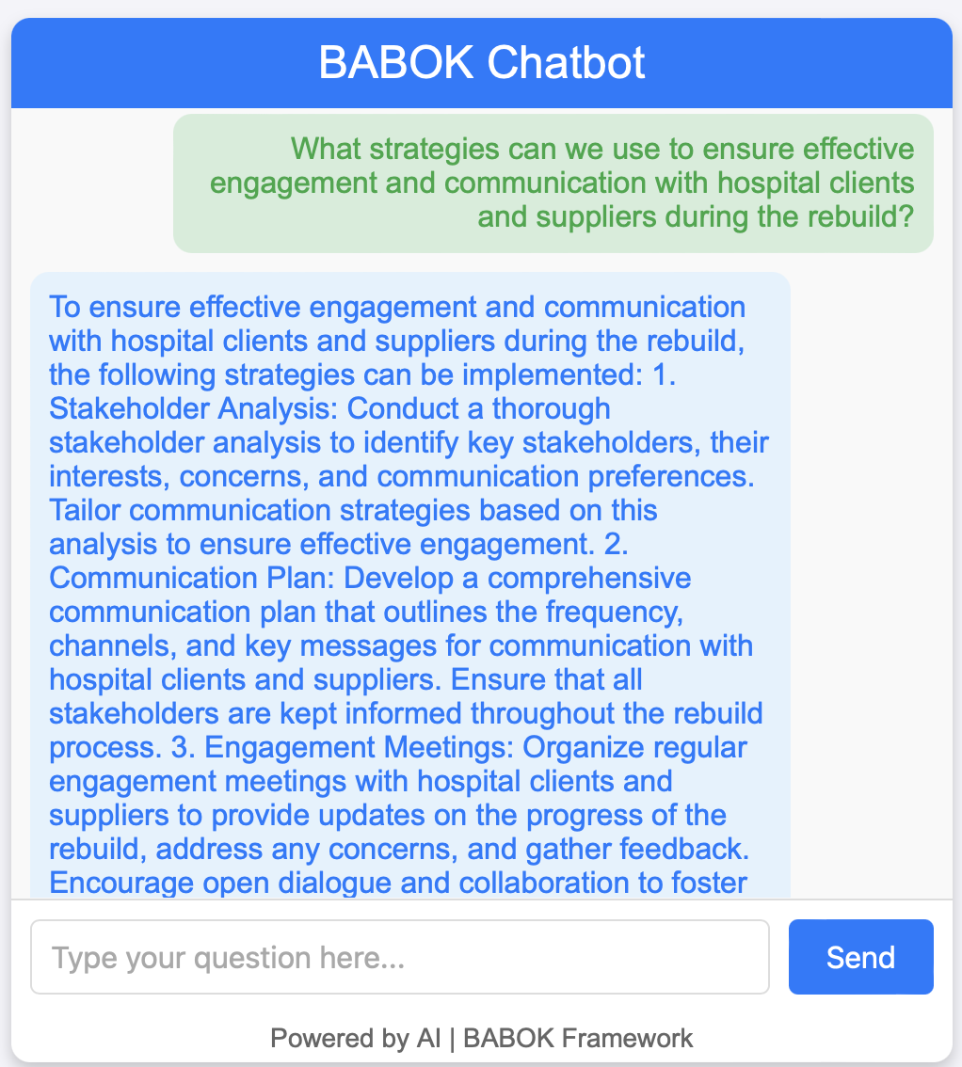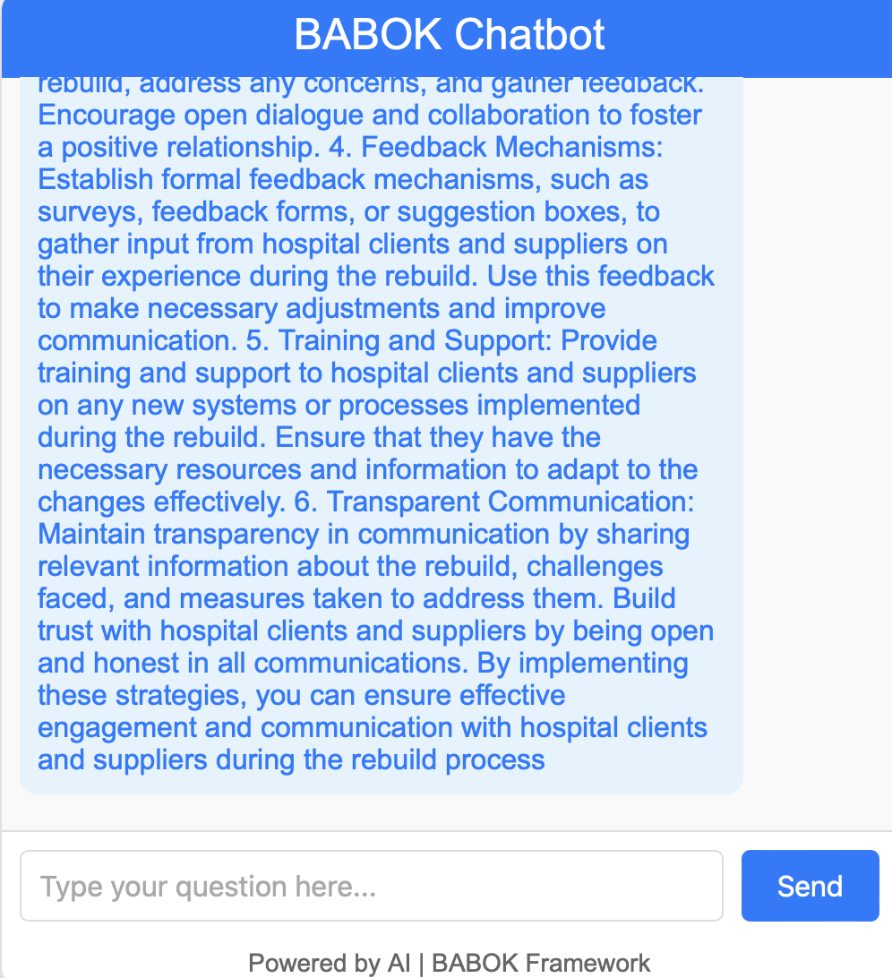

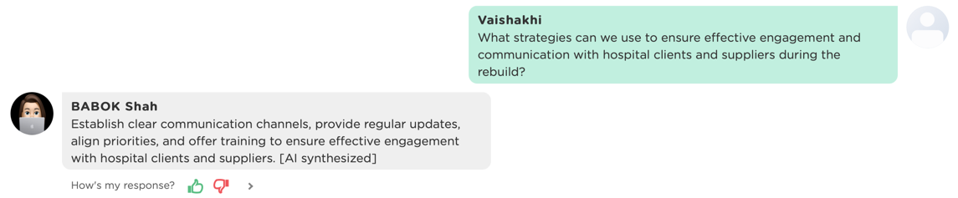

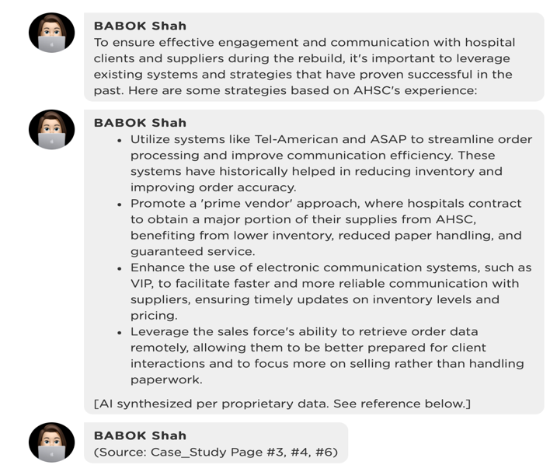

**3. Plan Business Analysis Governance (Task 3.3)**

* **Objective:** Test if the chatbot guides the user in setting up governance structures for decision-making and oversight.
* **Sample Questions:**
  + "What governance structures are recommended for an IT project of this scale, ensuring alignment with AHSC’s strategic goals?"

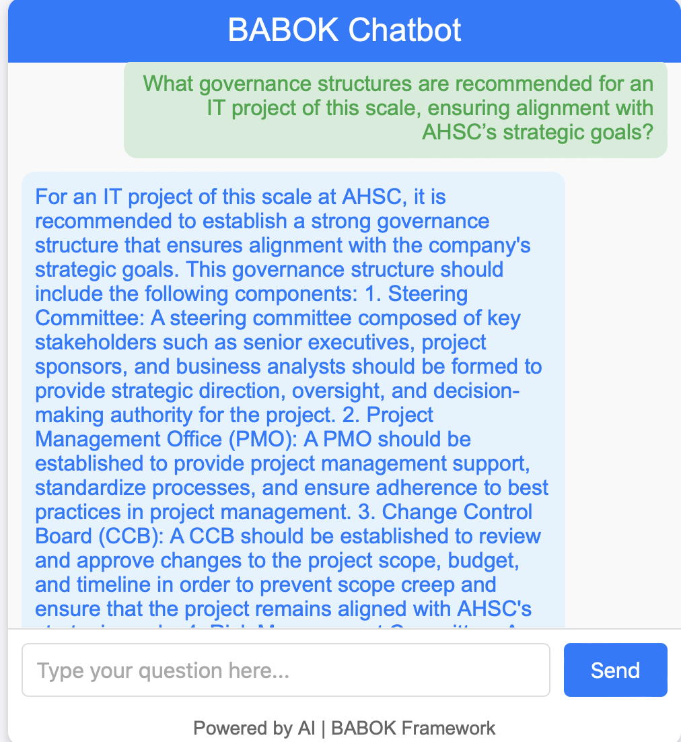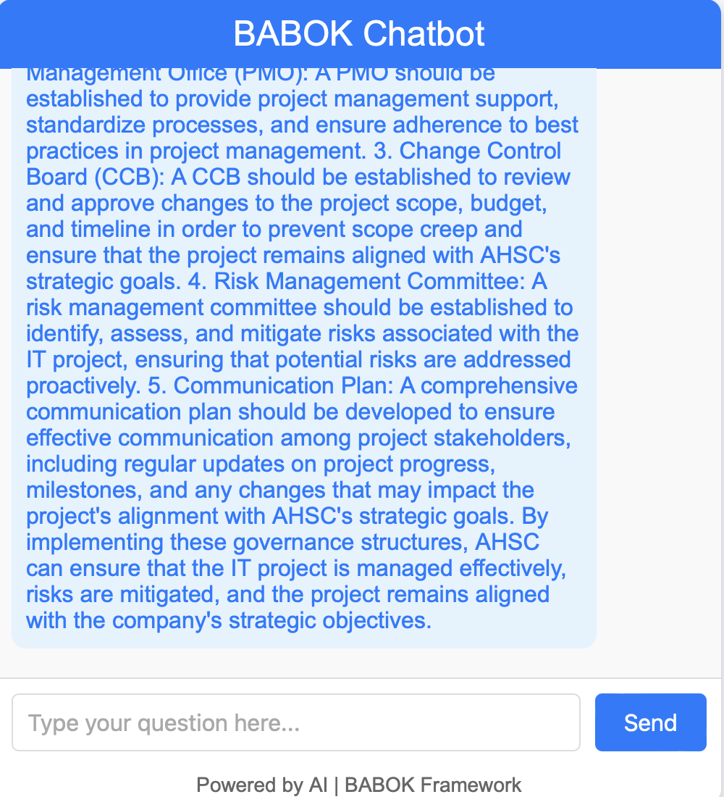

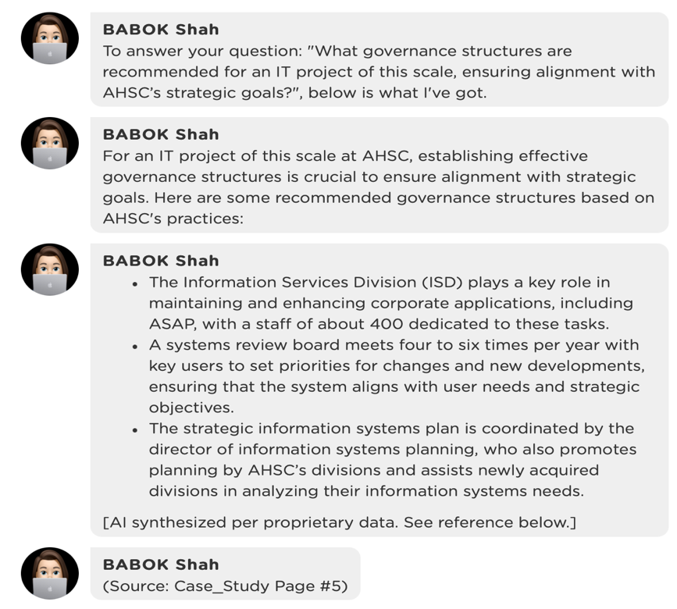

* + "How should decision-making authority be structured for changes in the rebuild of the ASAP system?"

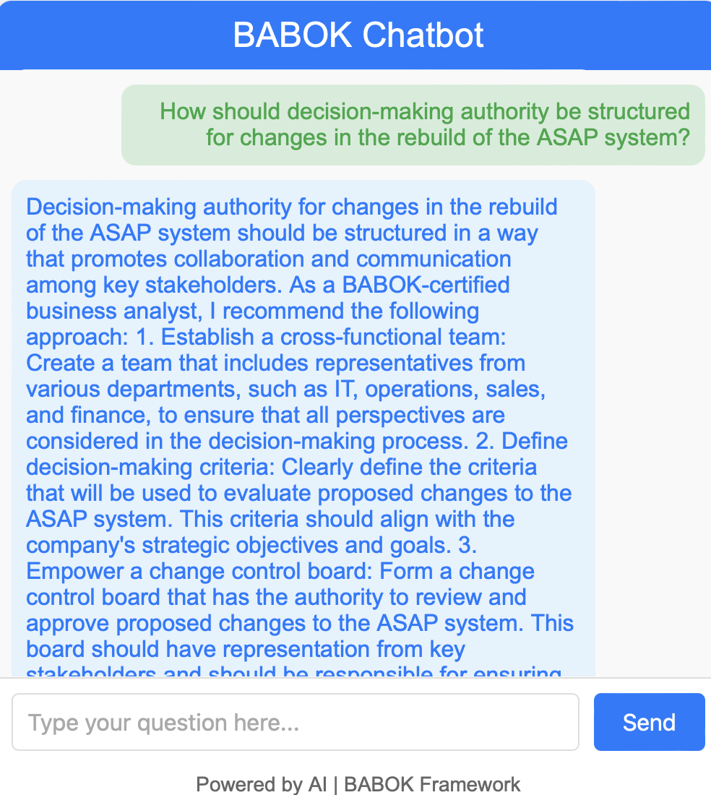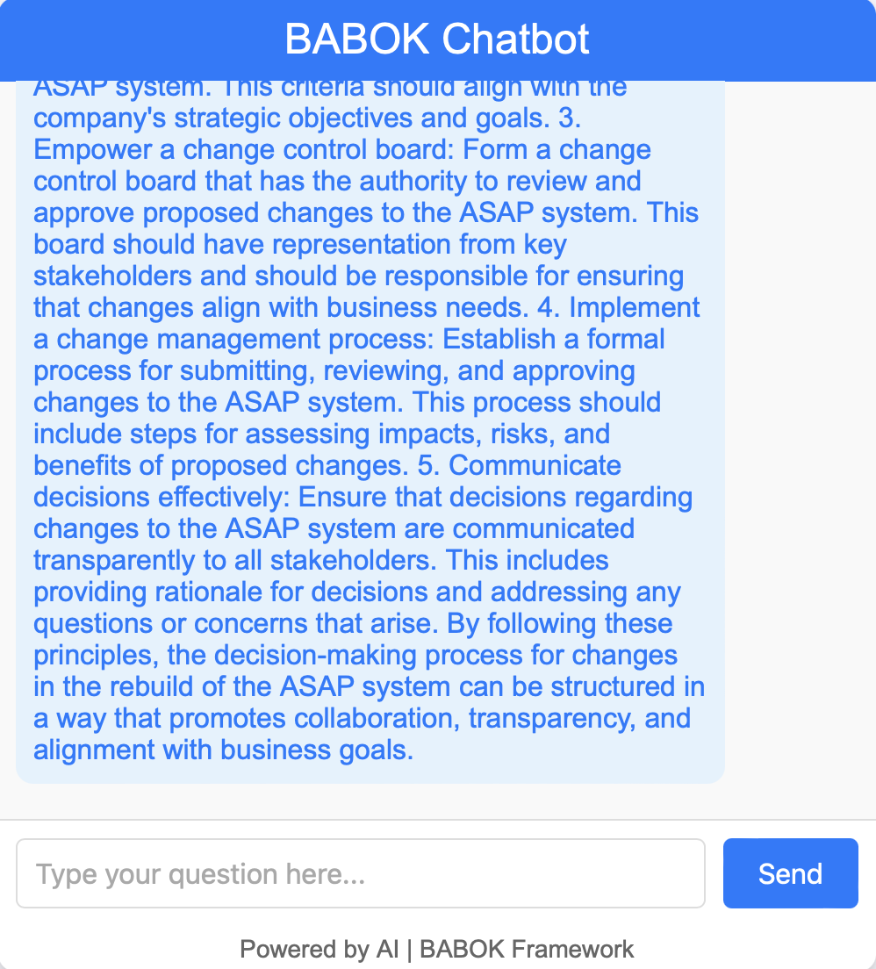

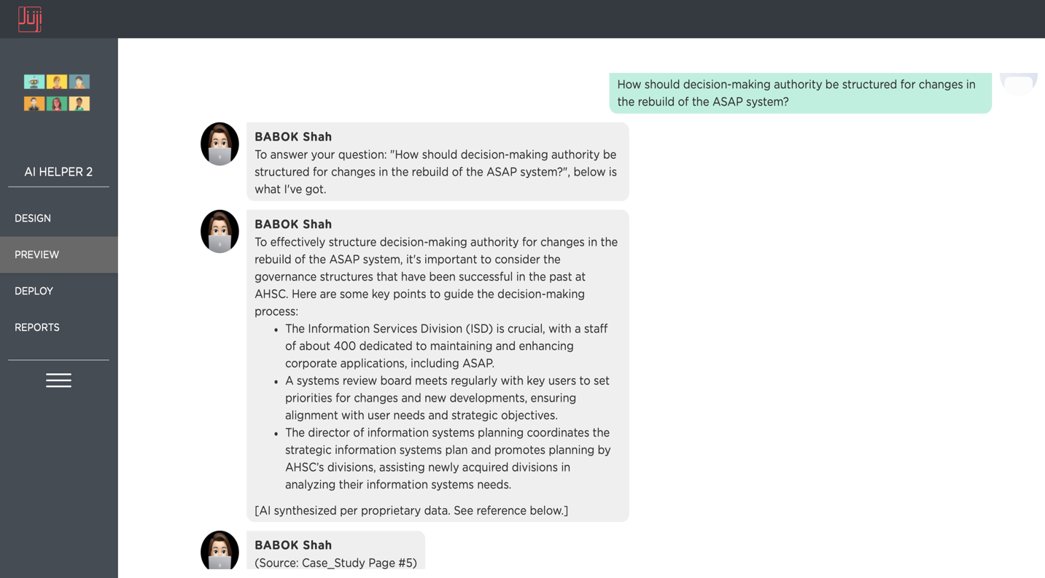

* + "What policies should we implement to handle project approvals, especially when new features are requested by clients?"

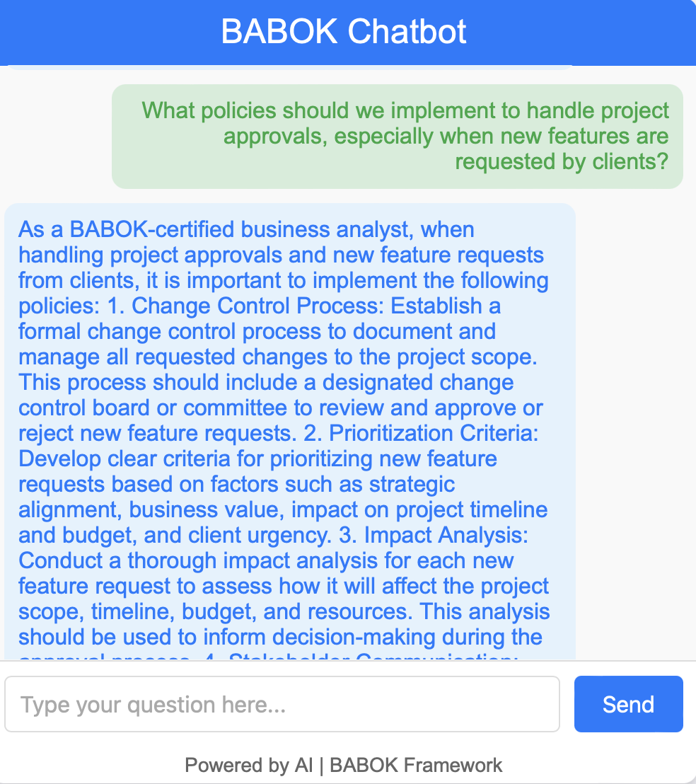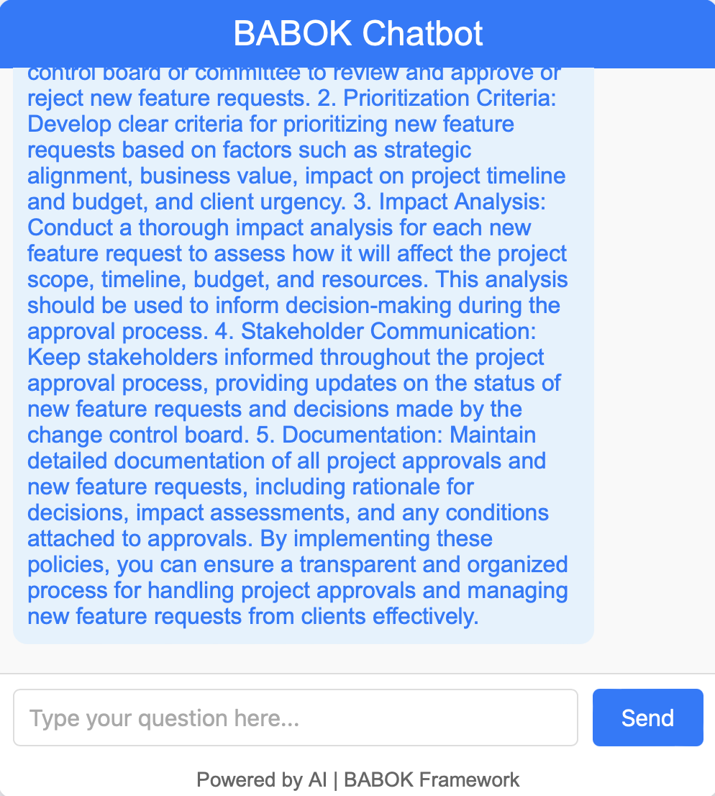

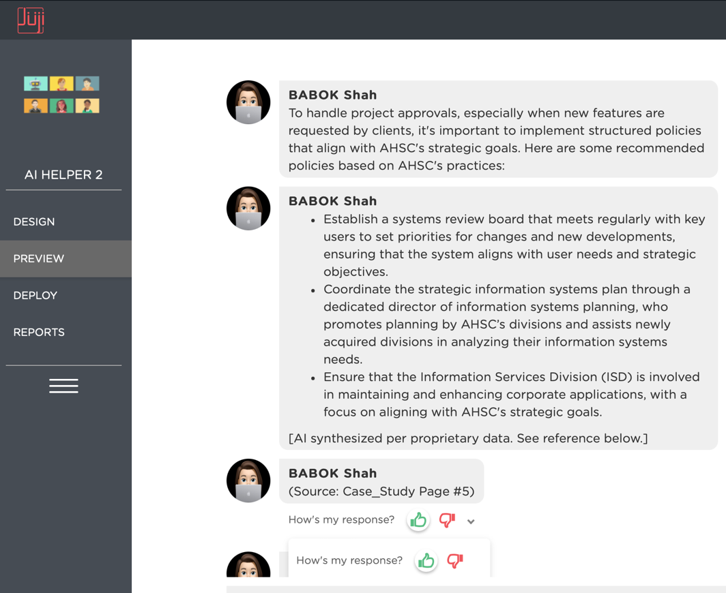

**4. Plan Business Analysis Information Management (Task 3.4)**

* **Objective:** Determine if the chatbot can advise on effective data and information management for the project.
* **Sample Questions:**
  + "What is the best way to manage and document requirements for the rebuild, considering ASAP’s historical complexity and the need for traceability?"

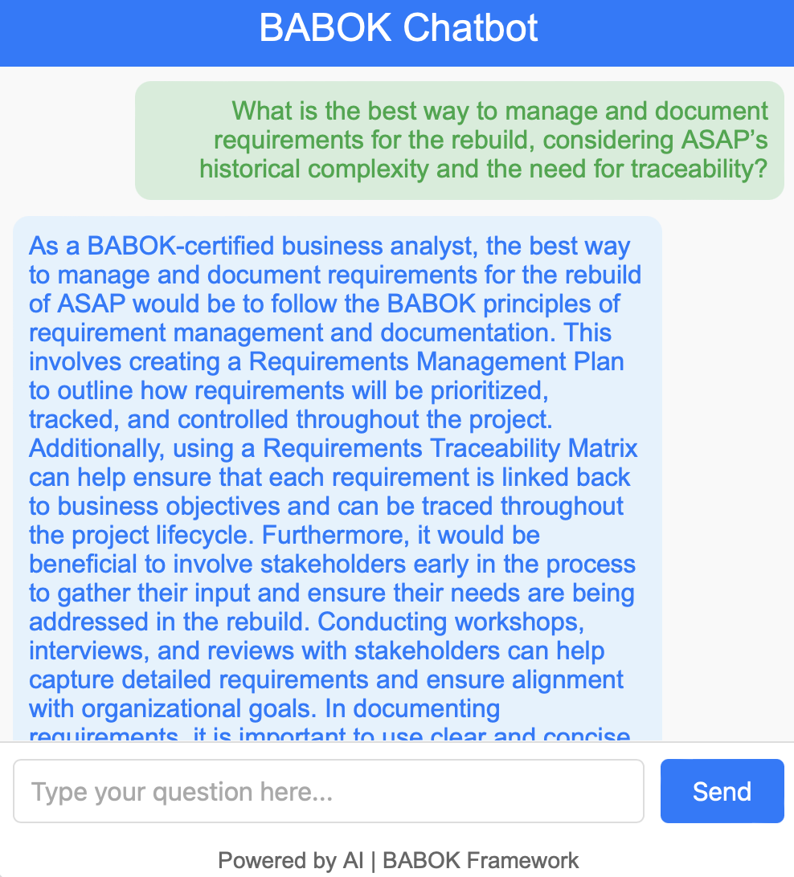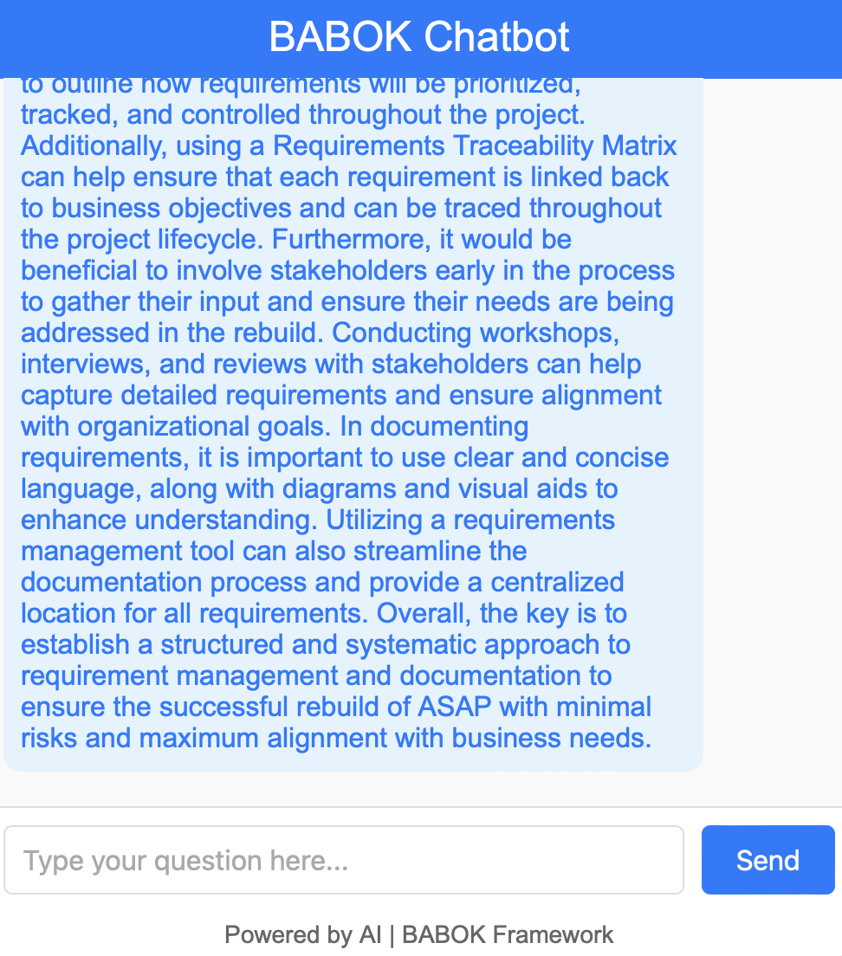

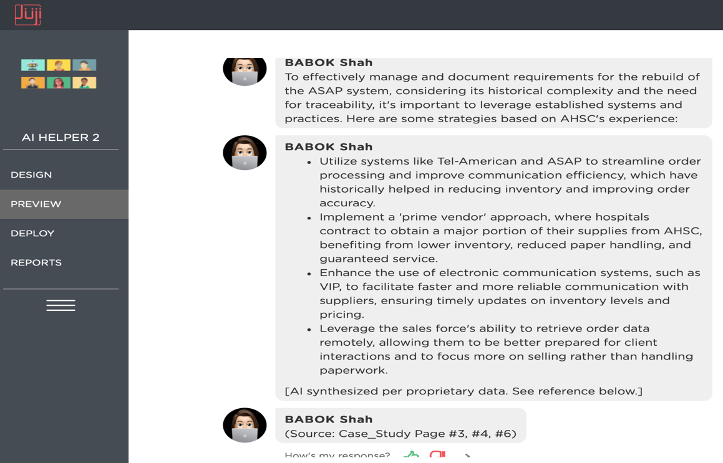

* + "How should we handle sensitive information, given the regulatory requirements for data privacy in healthcare?"

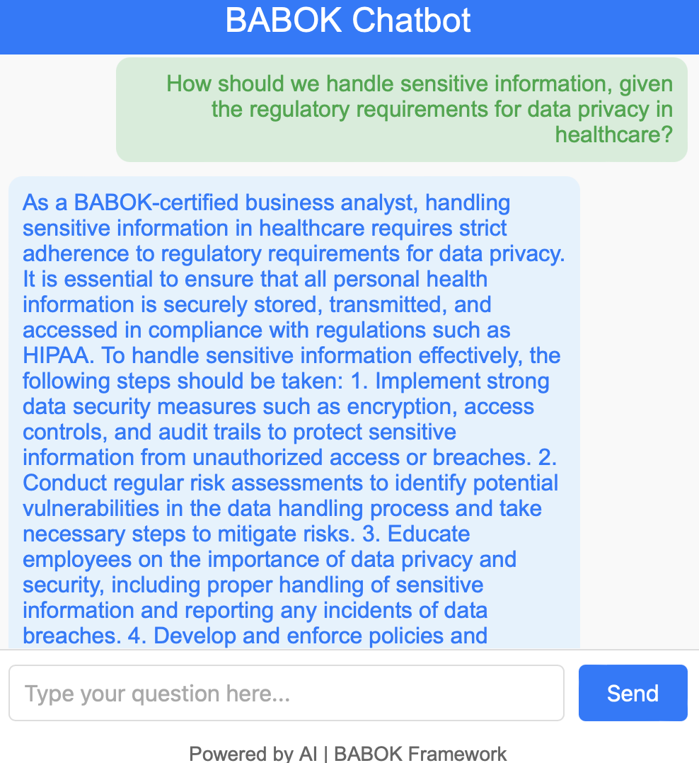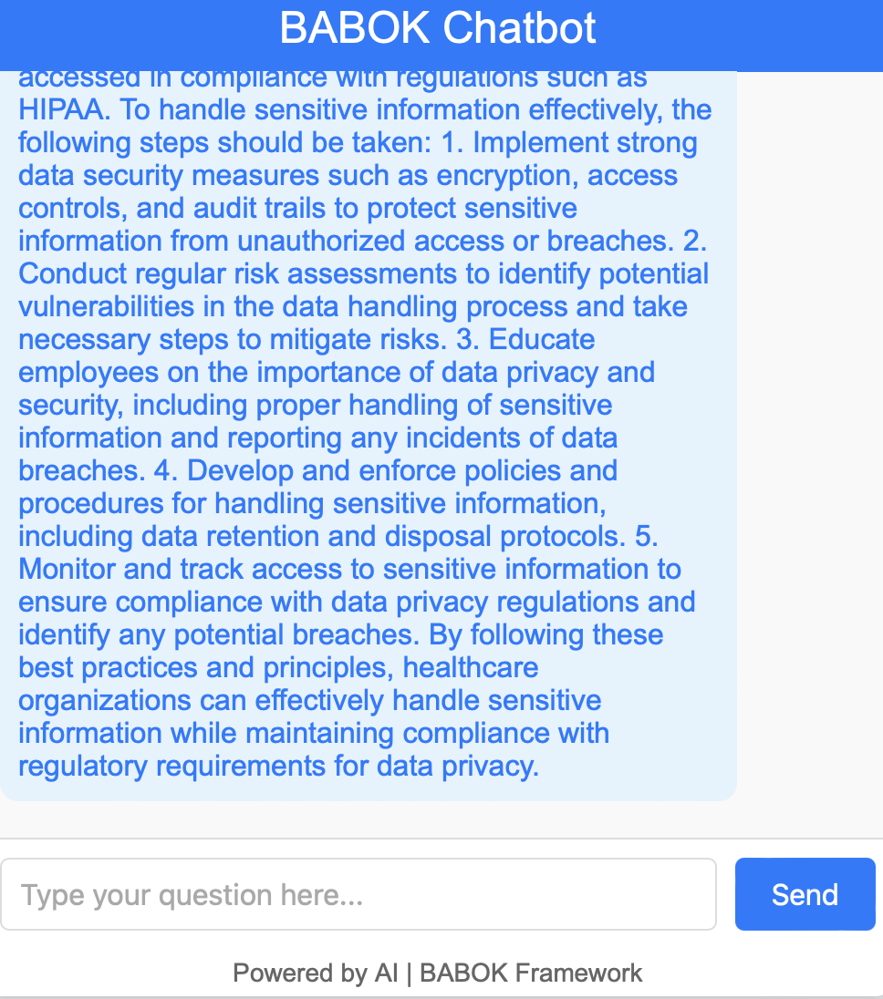

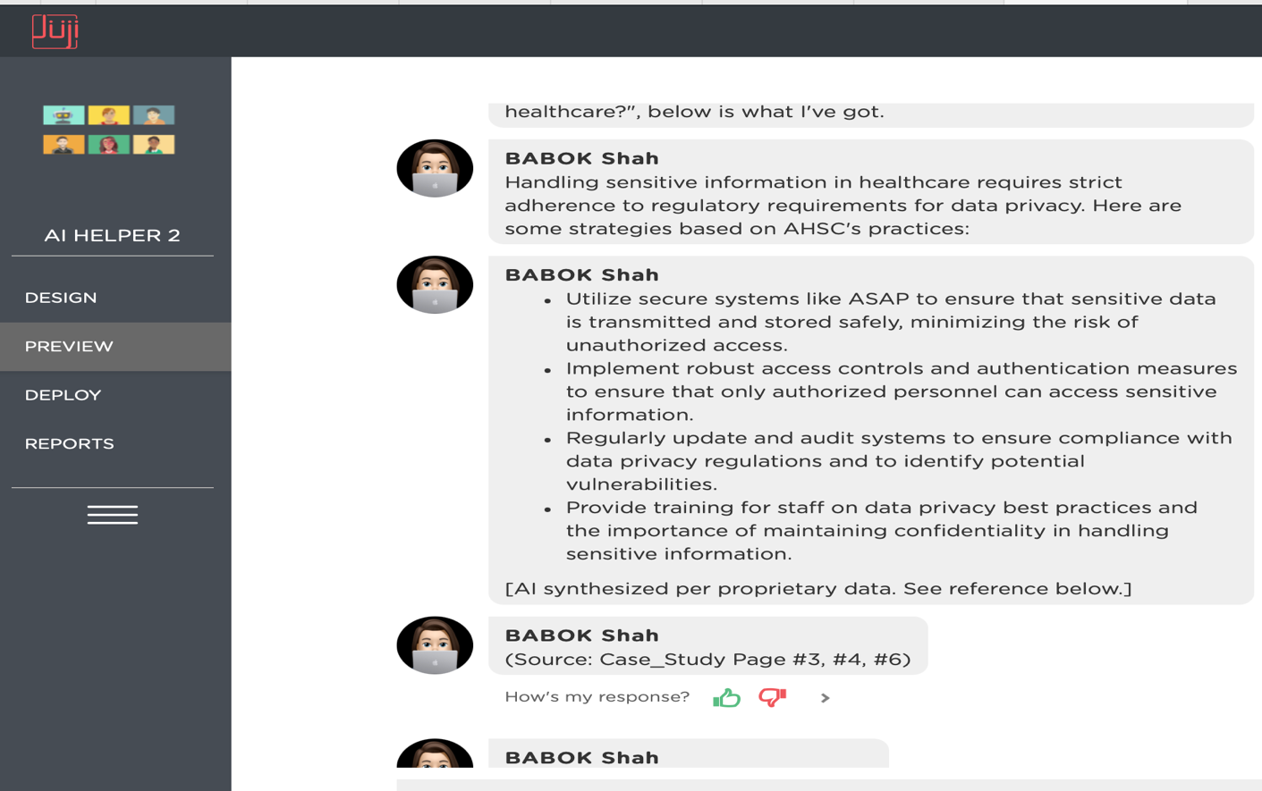

* + "What tools or processes should we consider for managing project documentation and ensuring version control?"

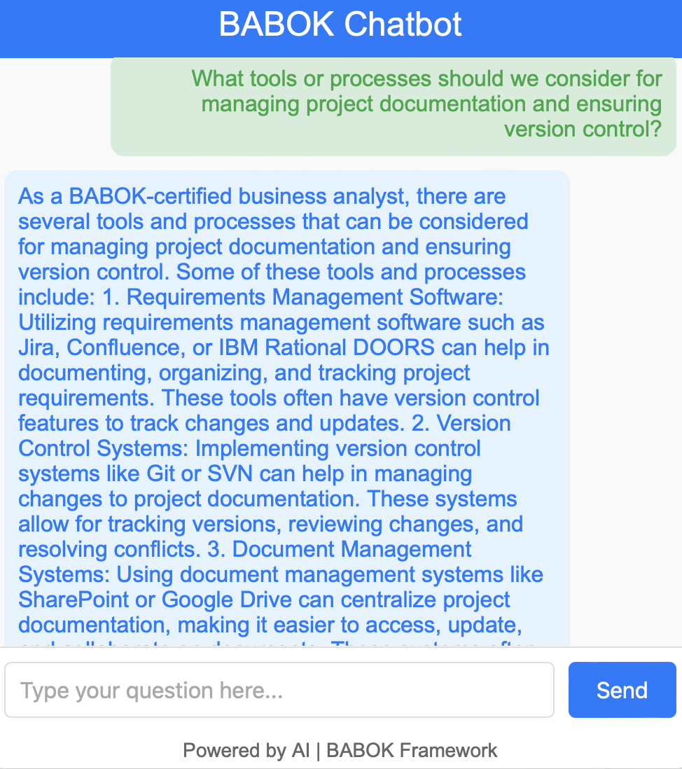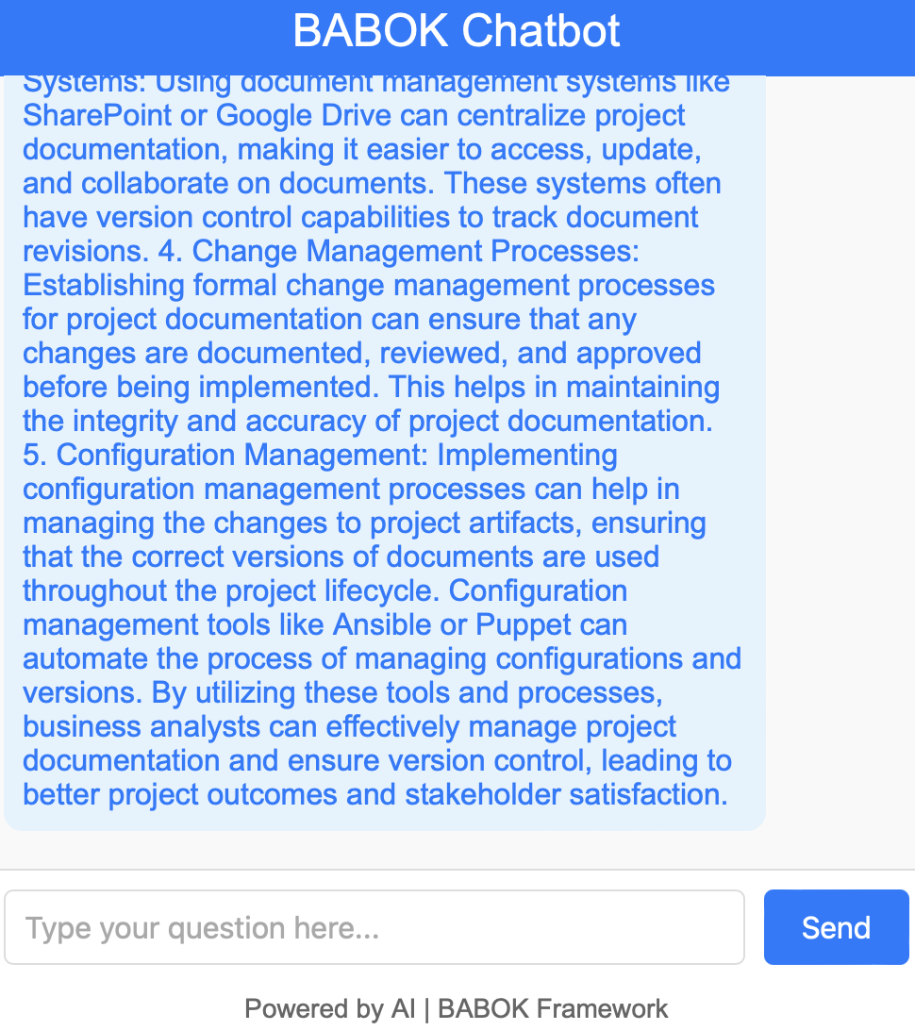

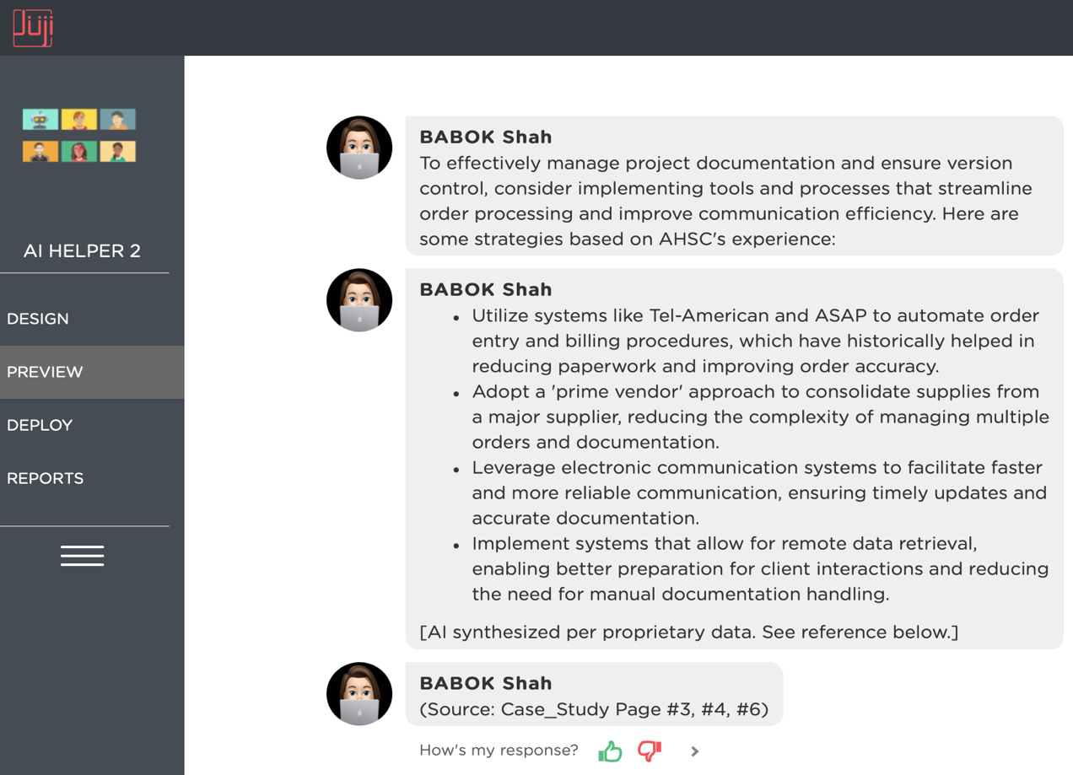

**5. Identify Business Analysis Performance Improvements (Task 3.5)**

* **Objective:** Assess if the chatbot can help identify and measure the effectiveness of business analysis activities.
* **Sample Questions:**
  + "What metrics should we establish to measure the success of the business analysis approach for the ASAP system rebuild?"

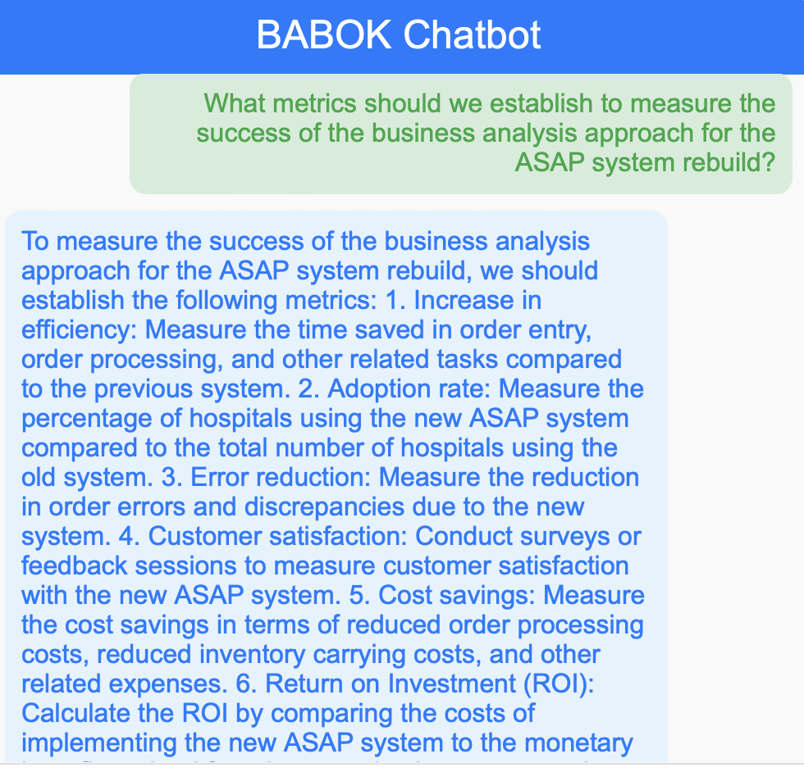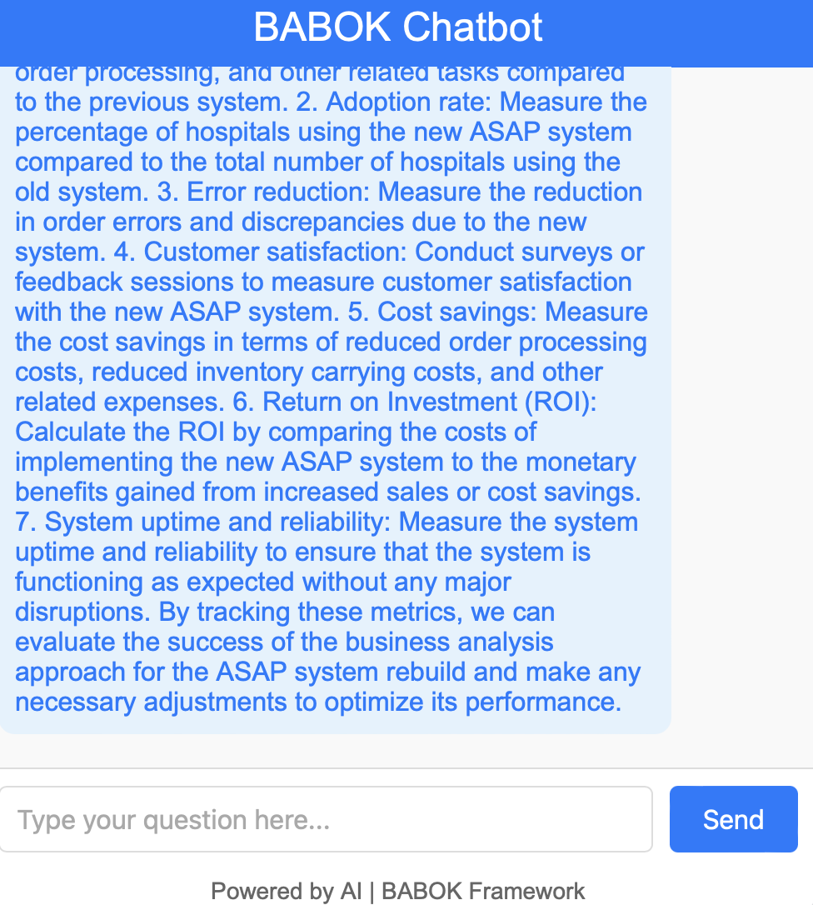

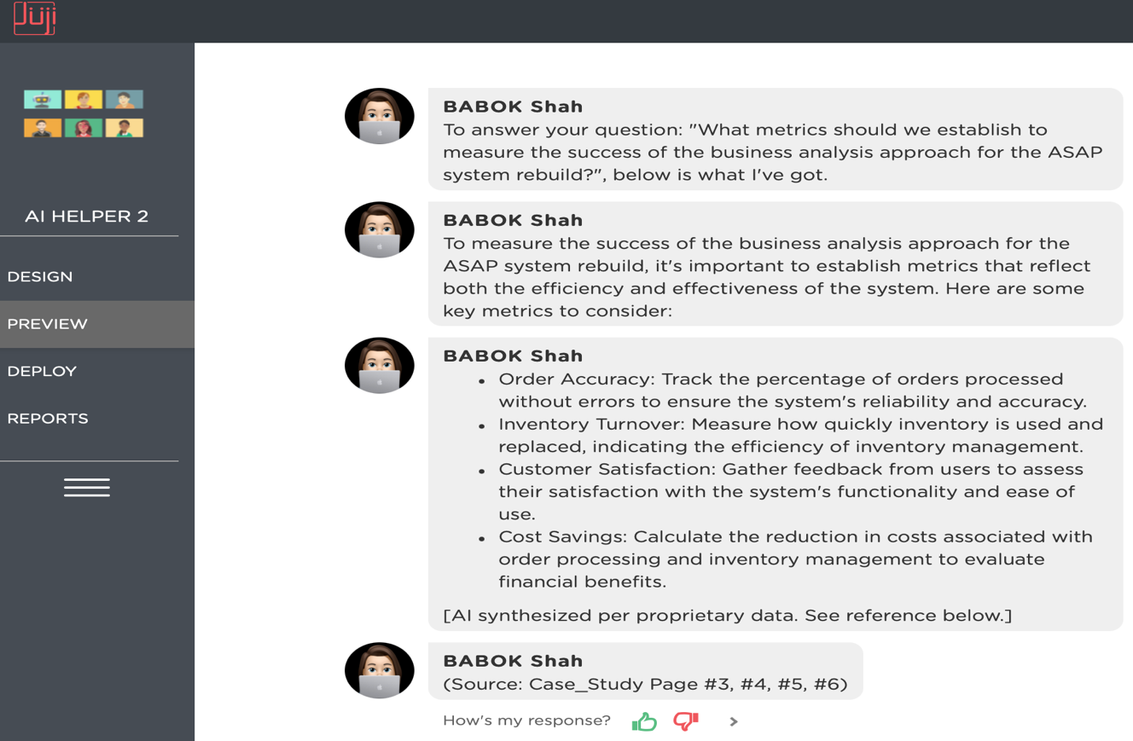

* + "How can we ensure continuous improvement in our business analysis practices throughout the project lifecycle?"

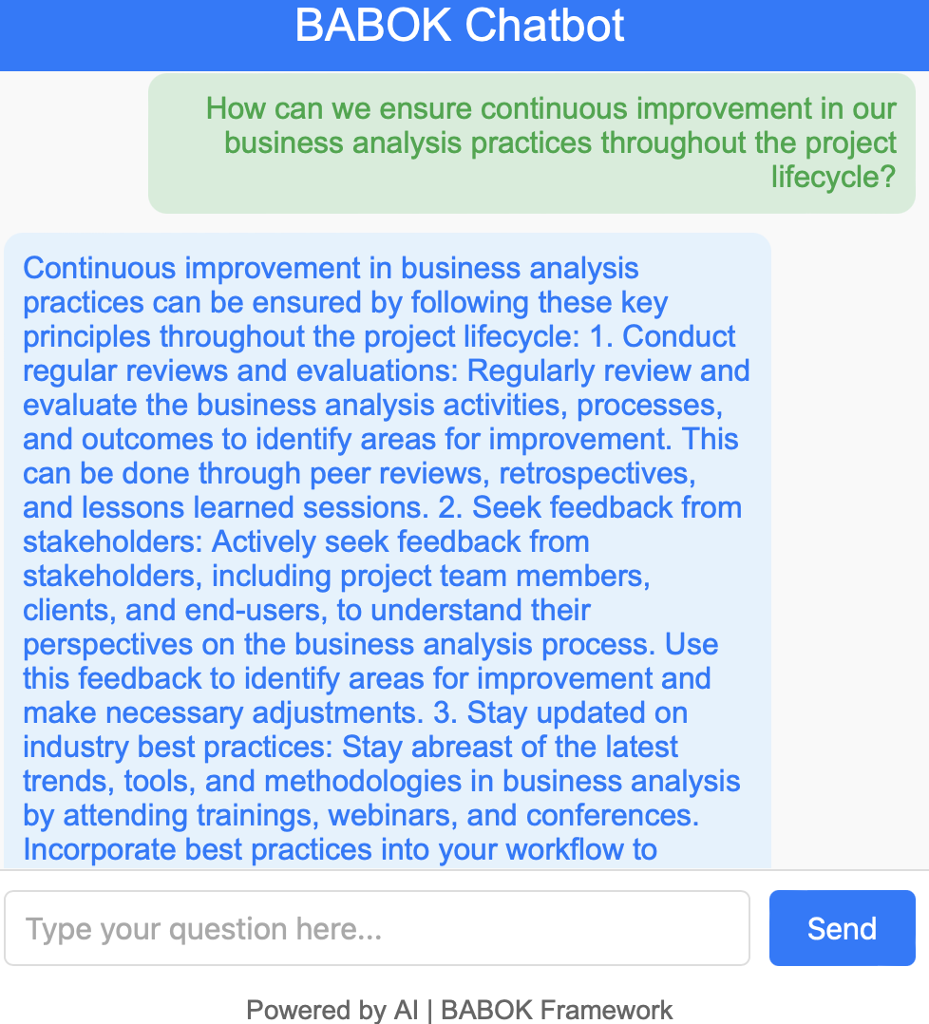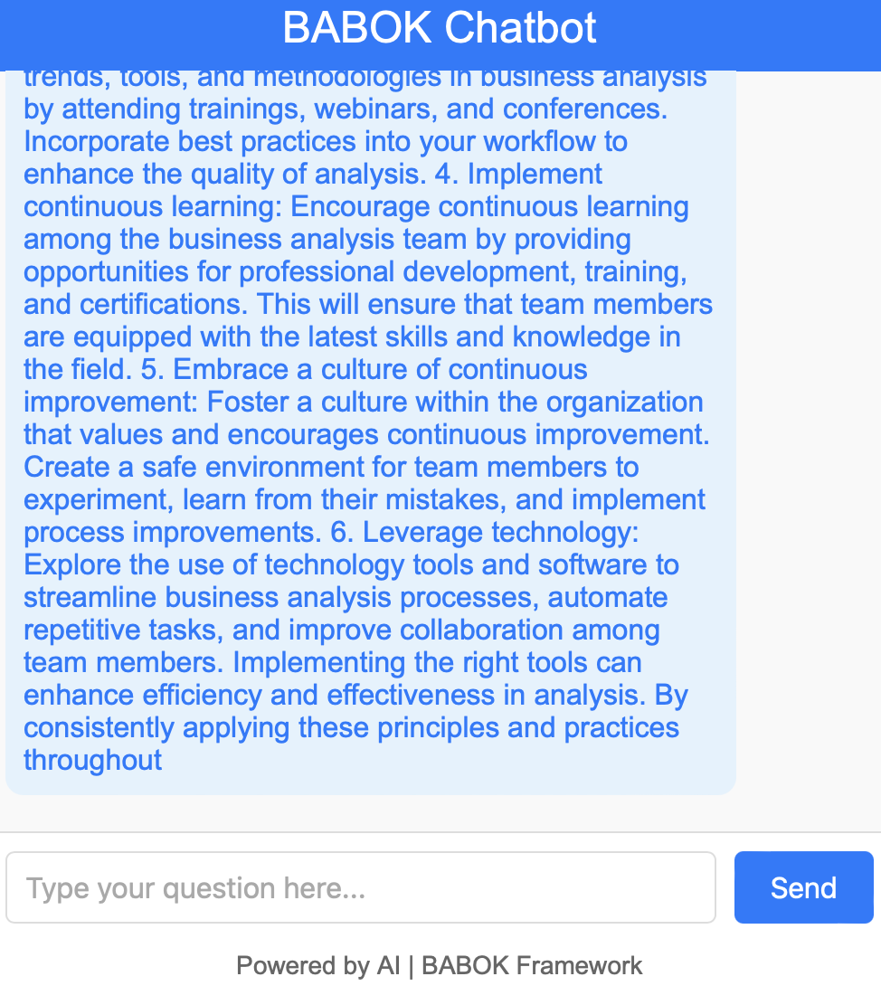

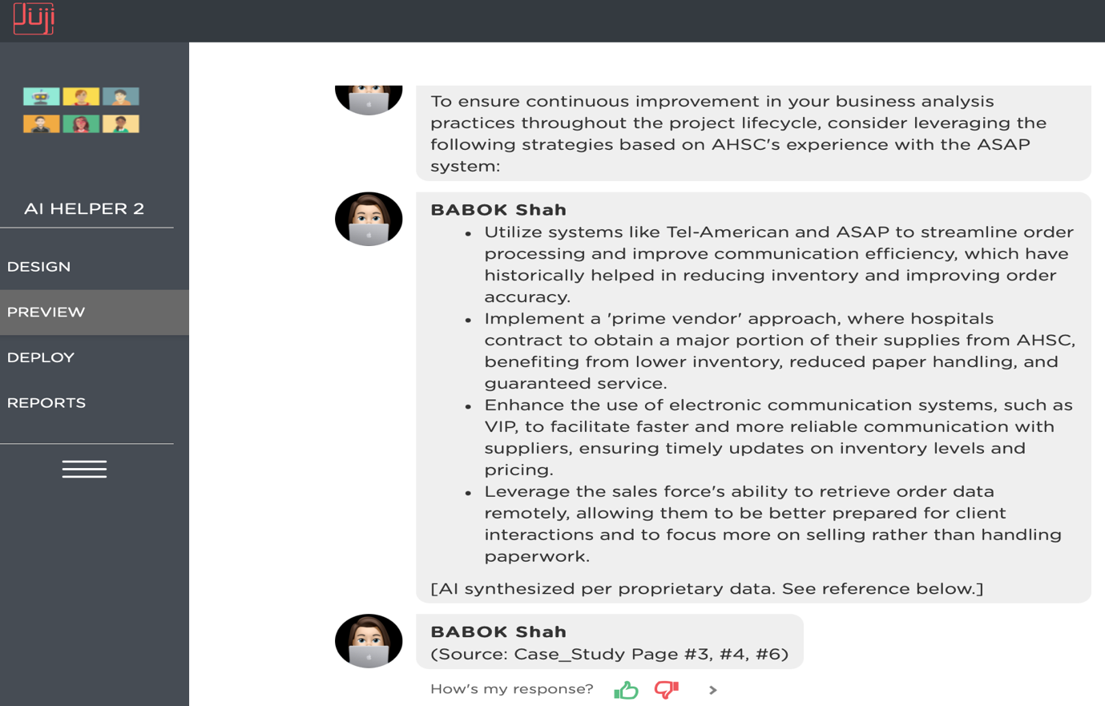

* + "What performance improvements should be targeted to better align the project outcomes with AHSC’s business objectives?"

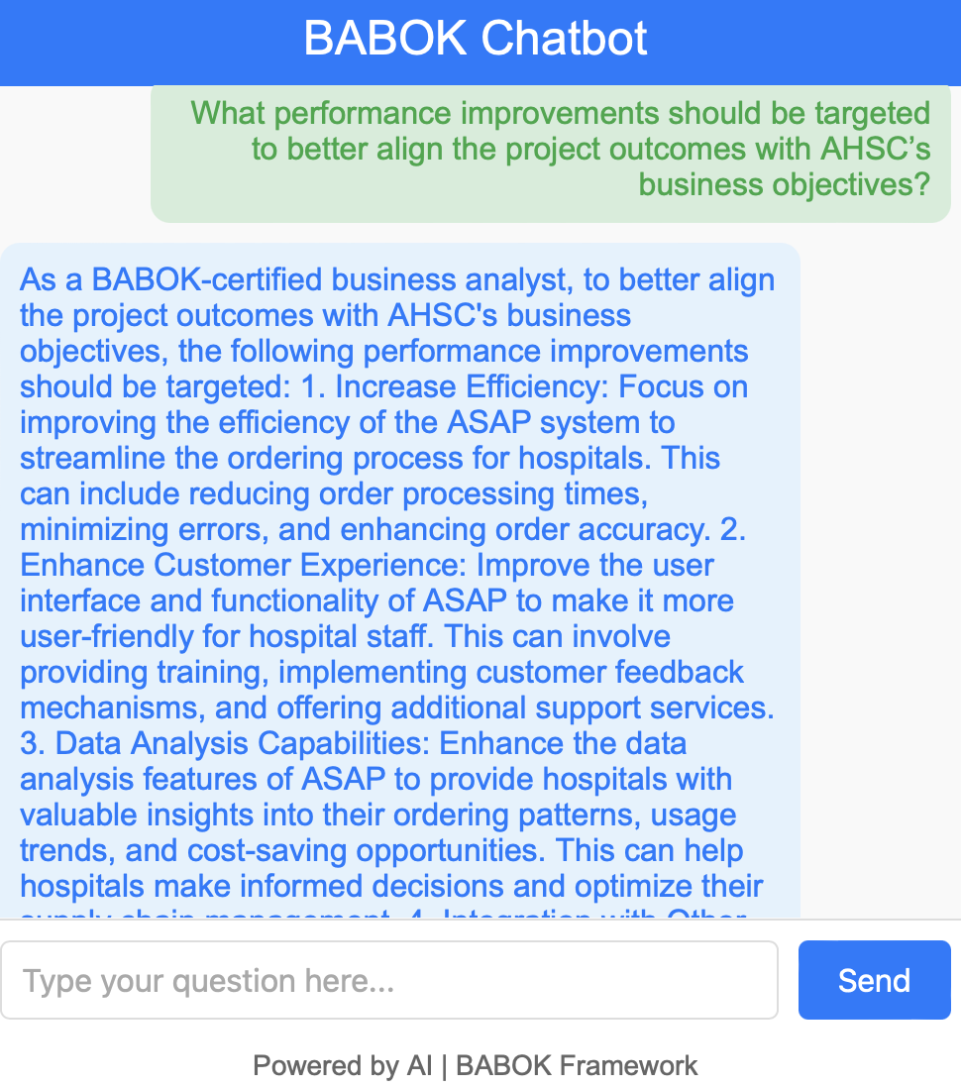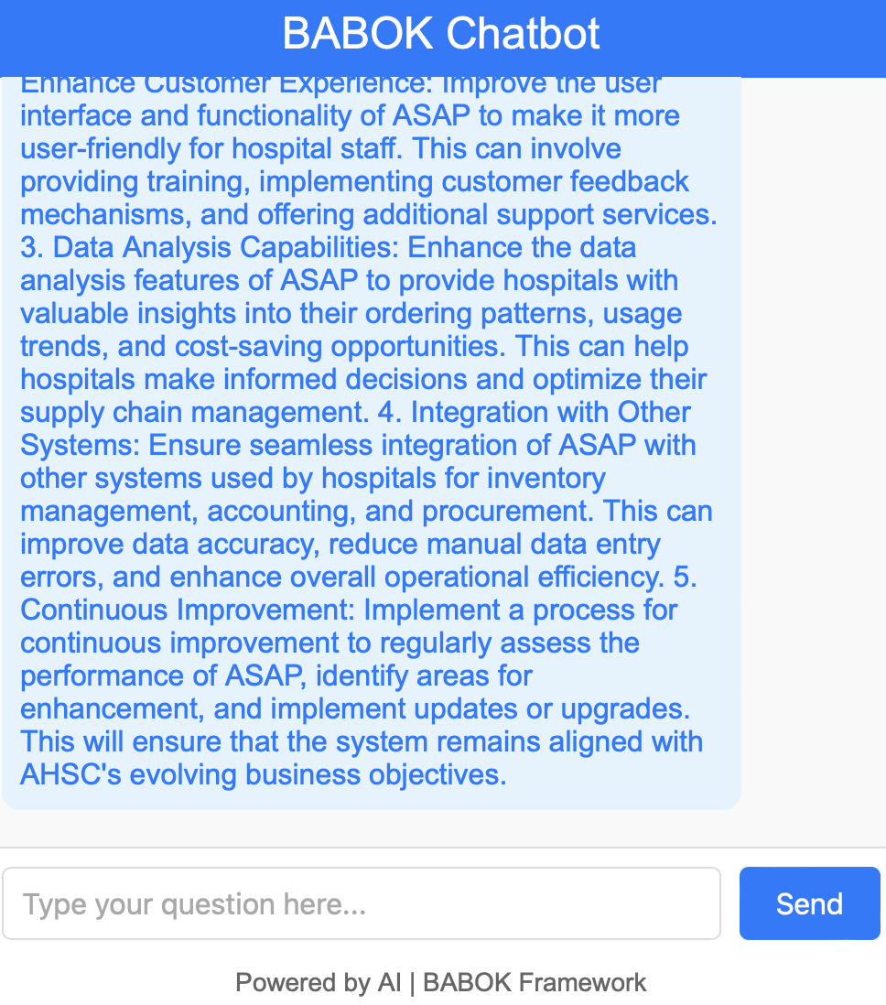

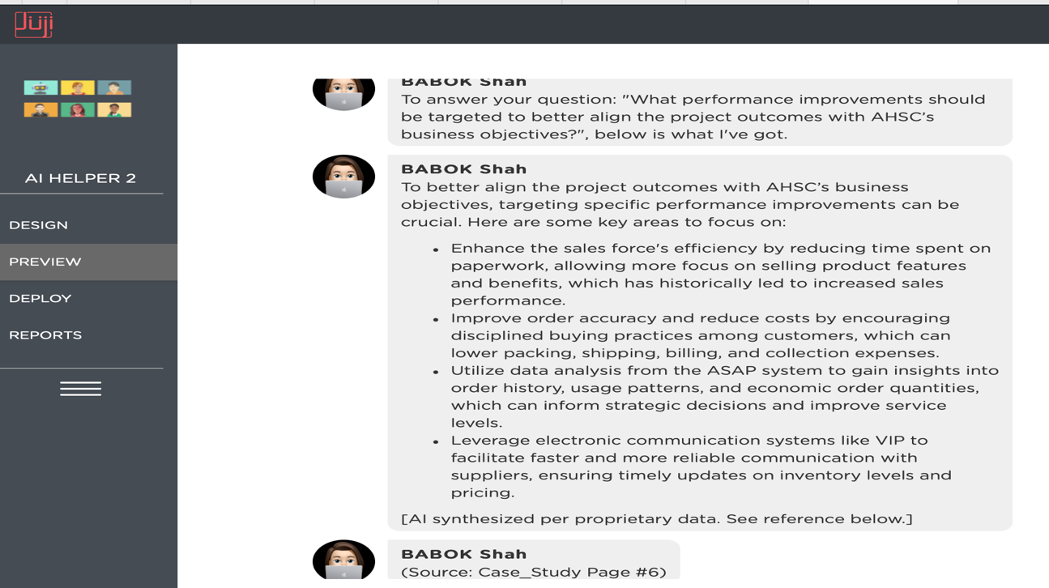

**Testing Method**

* **Instructions for Chatbot Testing:**
  + Engage with the chatbot by asking each of the above questions to see if it provides comprehensive and relevant responses based on BABOK principles.
  + Evaluate if the chatbot can adapt its responses based on follow-up questions or clarifications.
  + Note if the chatbot effectively uses BABOK terminology and guidance to simulate a real-world scenario.

This test should give a clear picture of the chatbot's ability to guide a user through the key tasks in Chapter 3 of BABOK, specifically within the context of the IT rebuild project in the provided Harvard case study.

**Summary**:

While both responses address the questions asked and finds the solution, **Response 1 for each question where we have used Python LLM Chatbot offers a broader, more generalized approach** whereas**Response** **2** **for each question where we have used Juji Studio appears more specific to the case.**